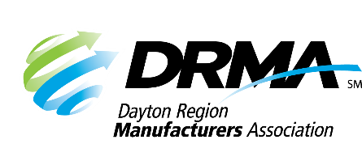
205 E. First St., Ste. 202
Dayton, OH 45402
(937) 949-4000 (937) 949-4007 fax
SKnoll@DaytonRMA.org www.DaytonRMA.org

DRMA Lean Manufacturing Series Registration Form

Please complete and return this form with payment to confirm your registration for the DRMA Lean Manufacturing Series, presented by the Workforce Division of Sinclair College. A certificate will be provided with completion at the end of each session.

Course Options
Session #1 – Lean Overview and Workplace Organization – Thursday, February 22
Session #2 – Visual Workplace/Standardized Work – Thursday, April 11
Session #3 – Value Stream Mapping – Thursday, June 20
Session #4 – Set-Up Reduction – Thursday, August 22
Session #5 – Total Preventative Maintenance (TPM) – Thursday, October 17

Time: 8:00 – 11:30 a.m.

Location: All courses will be held at the Sinclair’s Centerville Campus (5800 Clyo Rd., Centerville, OH 45459).

Cost: $175 per course, per person. All courses include a continental breakfast and individualized support from the instructor on an improvement project selected by each participating company. Notice of cancellation must be received by end of day on the Thursday prior to the class in order to receive a refund.

Registrant Information
Company: |  |  | Course Selections
Name | Title | Email | #1 | #2 | #3 | #4 | #5

Payment Information
Number of Participants: |  | X Number of Courses: |  | X $175 = | TOTAL = $

Check (make payable to DRMA) |  |  |  |  |  |  |  |  |  |  | Credit card (all major cards accepted)
Card #:
Exp. Date: |  |  |  |  |  | CVV Code: |  |  |  |  |  |  |  | Billing Zip Code:

Return this form with payment to the DRMA office.

