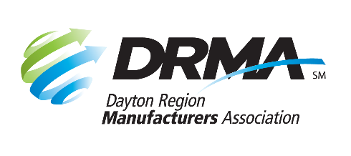
205 E. First St., Ste. 202
Dayton, OH 45402
(937) 949-4000 (937) 949-4007 fax
SKnoll@DaytonRMA.org www.DaytonRMA.org

DRMA GD&T and Blueprint Reading Workshops
Registration Form

DRMA is pleased to announce Blueprint Reading and GD&T workshops exclusively for DRMA members, offered in partnership with the Workforce Development Division of Sinclair Community College.

Blueprint Reading Workshop
Date: Friday, May 12
Time: 8:00 a.m. – 12:00 p.m.
Location: Sinclair’s Centerville Campus (5800 Clyo Rd., Centerville 45459)
Cost: $140 per person*

GD&T Workshop
Session Dates: Session #1 – Friday, June 2; Session #2 - Friday, June 9
Time: 8:00 – 11:00 a.m.
Location: Sinclair Conference Center (301 W. Fourth St., Dayton 45402), Building 12, Room 282
Cost: $195 per person for both sessions*

Price includes parking and continental breakfast. GD&T Workshop attendees will receive a copy of the GD&T Hierarchy Pocket Guide as part of their participation. Notice of cancellation must be received 8 business days prior to the workshop to receive a refund.

* Participants will complete a short form at the beginning of each workshop to qualify for the price listed on this form.

Registrant Information
Company: |  |  | Blueprint | GD&T
Name | Title | Email

Payment Information
Number of Blueprint Reading Participants: |  | x $140 =
Number of GD&T Participants |  | x $195 =
 |  |  | TOTAL = $

Check (make payable to DRMA) |  |  |  |  |  |  |  |  |  |  | Credit card (all major cards accepted)
Card #:
Exp. Date: |  |  |  |  |  | CVV Code: |  |  |  |  |  |  |  | Billing Zip Code:

Return this form with payment to the DRMA office.
If you prefer, you may call the office at 937-949-4000 to place your payment with DRMA staff after you’ve emailed/faxed your form.

