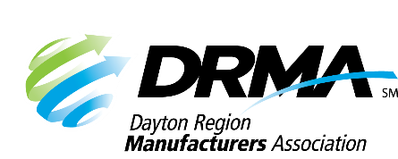
DRMA
22 E. Fifth St. ● Dayton, OH 45402
P: (937) 949-4000 ● F: (937) 949-4007
SKnoll@DaytonRMA.org ● www.DaytonRMA.org

DRMA Lean Manufacturing Series Registration Form

Please complete and return this form with payment to confirm your registration for the DRMA Lean Manufacturing Series, presented by the Workforce Division of Sinclair College. A certificate will be provided with completion at the end of each session.

Course Options
Session #1 – Lean Overview and Workplace Organization – Thursday, February 26
Session #2 – Visual Workplace/Standardized Work – Thursday, April 30
Session #3 – Value Stream Mapping – Thursday, June 11
Session #4 – Set-Up Reduction – Thursday, August 20
Session #5 – Total Preventative Maintenance (TPM) – Thursday, November 5

Time: 8:00 – 11:30 a.m.

Location: All courses will be held at the Sinclair’s Centerville Campus (5800 Clyo Rd., Centerville, OH 45459).

Cost: $225 per course, per person. All courses include a continental breakfast and individualized support from the instructor on an improvement project selected by each participating company. Notice of cancellation must be received by end of day on the Thursday prior to the class to receive a refund.

Registrant Information
Company: |  |  | Course Selections
Name | Title | Email | #1 | #2 | #3 | #4 | #5

Payment Information
Number of Participants: |  | X Number of Courses: |  | X $225 = | TOTAL = $

Check (make payable to DRMA) |  |  |  |  |  |  |  |  |  |  | Credit card (all major cards accepted)
Card #:
Exp. Date: |  |  |  |  |  | CVV Code: |  |  |  |  |  |  |  | Billing Zip Code:

Return this form with payment to the DRMA office.

