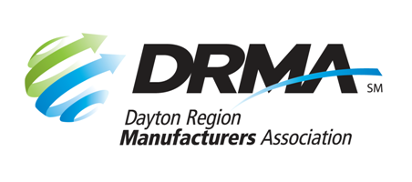
22 E. Fifth St. Dayton, OH 45402
P: (937) 949-4000 F: (937) 949-4007
www.daytonrma.org

SPONSORSHIP ORDER FORM
Annual Meeting
December 2, 2026 – NCR Country Club

Promote your products, services, and expertise at the DRMA Annual Meeting held in early December. Anticipated attendance is 120+. Contact the DRMA office at (937) 949-4000 or Events@DaytonRMA.org.

 | Presenting Sponsor  $1,000  (1 available) | Supporting Sponsor  $500  (unlimited)
Name appears as “presented by” on all event promotion (newsletter, emails, website, etc.) | 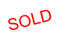  Yes
Recognition on DRMA website event page and PowerPoint presentation | Logo | Name
Newsletter article (written by you) | 1
Complimentary tickets  for sponsor’s guests or employees | 4 | 2
Sponsor ribbons  on all sponsor employees’ name badges | Yes | Yes
Display table at event | Yes | Yes
Recognition during program | Make remarks (1 minute) | Company name & promotional sentence in script
Literature/giveaways on tables  provided by you | Yes
Attendee list (name and company name) | Yes
Sponsorship selected: | ☐ | ☐

Details regarding format, content, logistics, etc., will be discussed with you before the event.

Company: |  | Phone:
Contact Name: |  | Email:
Date Submitted: |  | Total $:

Check (make payable to DRMA) |  |  |  |  |  |  |  |  |  | Credit card (all major cards accepted)
Card #:
Exp. Date: |  |  |  |  |  | CVV Code: |  |  |  |  |  |  | Billing Zip Code:

Return this form with payment to the DRMA office.
If you prefer, you may call the office at 937-949-4000 to place your payment with DRMA staff after you’ve emailed/faxed your form.

