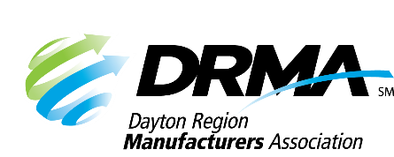
DRMA
22 E. Fifth St. ● Dayton, OH 45402
P: (937) 949-4000 ● F: (937) 949-4007
SKnoll@DaytonRMA.org ● www.DaytonRMA.org

DRMA Emerging Leaders Circle
Registration Form

Please complete and return this form with payment to confirm your registration for DRMA’s Emerging Leaders Circle. presented by DRMA member Brixey & Meyer.

Workshop Sessions:
- Leading from Your Vantage Point – Navigating from Your Unique Perspective – Tuesday, February 17
- Defeating Your Inner Critics – Confronting Your Saboteurs – Tuesday, March 10
- Developing a Purpose-Driven Leadership Style – Tuesday, April 7
- Cultivating a Growth Mindset – Embracing Continuous Improvement – Tuesday, April 28
- Handling Challenging Conversations – Communicating for Success – Tuesday, May 19
- Creating a Culture of Trust – Driving Clarity, Alignment, and Accountability – Tuesday, June 23
- Unleashing Creativity in the Workplace – Inspiring Innovation – Tuesday, July 21
- Leading at Your Level – Delegating and Prioritizing Your Work - Tuesday, August 18
- Fact v. Fiction – Exploring Labor Market Trends – Tuesday, September 22
- Reflections on Learnings and Plans for Long-Term Growth – Tuesday, October 20

Time: 8:00 – 11:00 a.m.

Location: All courses will be held Brixey & Meyer’s Miamisburg office (2991 Newmark Rd., Miamisburg, OH 45432).

Cost: $3,200 per person for 10 workshop sessions and a talent summit. Notice of cancellation must be received two weeks prior to the first course to receive a refund.

Registrant Information

Company: |  |  | Email receipt to:
Name | Title | Email | Registrants’ direct supervisor | Supervisors email*

Payment Information
Number of Participants: |  | X $3,200 = | TOTAL = $

Check (make payable to DRMA) |  |  |  |  |  |  |  |  |  |  | Credit card (all major cards accepted)
Card #:
Exp. Date: |  |  |  |  |  | CVV Code: |  |  |  |  |  |  |  | Billing Zip Code:

Return this form with payment to the DRMA office.
If you prefer, you may call the office at 937-949-4000 to place your payment with DRMA staff after you’ve emailed/faxed your form.

