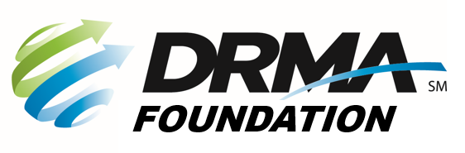
DRMA
22 E. Fifth St. ● Dayton, OH 45402
P: (937) 949-4000 ● F: (937) 949-4007
Events@DaytonRMA.org ● www.DaytonRMA.org

DRMA Fall Golf Outing Registration Form
Presented by Gosiger
Date: Monday, September 29, 2025 Time: 7:30 a.m. Morning session
Place: Miami Valley Golf Club 12:30 p.m. Afternoon session
3311 Salem Ave. 5:30 p.m. Cocktails (cash/credit card bar)
Attire: Proper golf attire; no jeans permitted 6:30 p.m. Dinner
Contact Name: |  |  |  | Email:
Phone: |  |  | DRMA Member Company:

Return this form with payment to the DRMA office. If you prefer, you may call the office at 937-949-4000 to place your payment with DRMA staff after you’ve emailed/faxed your form. Sessions will be assigned on a first-come basis. Cancellations with refunds will be accepted through September 12. All name changes must be received by September 19. Confirmations will be emailed. Golf fees include cart, straightest drive contest, skins game, 1 mulligan per player, and lunch. The afternoon session is reserved for members only (participants must be employed by member companies). If you’d like to register non-members as your guests, you must play in the morning session.

Cart# | Player Name | Company Name | Golf | Morning  7:30 a.m. | Afternoon  12:30 p.m. | Dinner
1
1
2
2
3
3
4
4

Person/company you would like to play with:
 | # | Cost | Total
Golf only |  | x $250 = | $
Golf AND dinner |  | x $300 = | $
Dinner only |  | x $60 = | $
# of tee sign sponsorships |  | x $250 = | $
 |  | TOTAL | $

Check (make payable to DRMA Foundation) |  |  |  |  |  |  |  |  |  |  | Credit card (all major cards accepted)
Card #:
Exp. Date: |  |  |  |  |  | CVV Code: |  |  |  |  |  |  |  | Billing Zip Code:

Net proceeds from the outing will be contributed to the DRMA Foundation, a 501(c)3 organization. Consult your
professional income tax advisor to determine the amount which may be deductible as a business expense or a charitable contribution.

