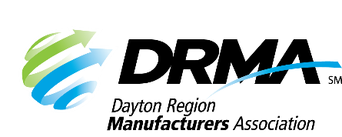
DRMA
22 E. Fifth St. ● Dayton, OH 45402
P: (937) 949-4000 ● F: (937) 949-4007
SKnoll@DaytonRMA.org ● www.DaytonRMA.org

DRMA Lean Manufacturing Series Registration Form

Please complete and return this form with payment to confirm your registration for the DRMA Lean Manufacturing Series, presented by the Workforce Division of Sinclair College. A certificate will be provided with completion at the end of each session.

Course Options
Session #1 – Visual Workplace/Standardized Work – Thursday, April 30
Session #2 – Value Stream Mapping – Thursday, June 11
Session #3 – Set-Up Reduction – Thursday, August 20
Session #4 – Total Preventative Maintenance (TPM) – Thursday, November 5

Time: 8:00 – 11:30 a.m.

Location: All courses will be held at Sinclair’s Centerville Campus (5800 Clyo Rd., Centerville, OH 45459).

Cost: Single class registration: $300 per person. 4-class bundle: $1000 per person. All courses include a continental breakfast and individualized support from the instructor on an improvement project selected by each participating company. Notice of cancellation must be received one week prior to the class to receive a refund.

Registrant Information
Company: |  |  | Course Selections
Name | Title | Email | #1 | #2 | #3 | #4

Payment Information
Number of single class registrations: |  | x $300 | Total = $
Number of 4-class bundles: |  | x $1,000 | Total = $
 |  |  | TOTAL = $

Check (make payable to DRMA) |  |  |  |  |  |  |  |  |  |  | Credit card (all major cards accepted)
Card #:
Exp. Date: |  |  |  |  |  | CVV Code: |  |  |  |  |  |  |  | Billing Zip Code:

Return this form with payment to the DRMA office.

