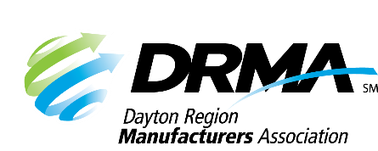
DRMA
22 E. Fifth St. ● Dayton, OH 45402
(937) 949-4000 ● (937) 949-4007 fax
SKnoll@DaytonRMA.org ● www.DaytonRMA.org

DRMA Supervisory Excellence Workshop Series
Registration Form

Please complete and return this form with payment to confirm your registration for DRMA’s Supervisory Excellence Workshop Series, presented by DRMA member Brixey & Meyer.

Course Options
Session #1 – Having the Courage to lead – Thursday, February 19
Session #2 – Leadership Pitfalls to Avoid – Thursday, March 12
Session #3 – Leading Self: Creating an Ownership Mindset (Part 1) – Thursday, April 16
Session #4 – Leading Self: Creating an Ownership Mindset (Part 2) – Thursday, May 14
Session #5 – Leading Teams: Creating an Ownership Culture (Part 1) – Thursday, June 25
Session #6 - Leading Teams: Creating an Ownership Culture (Part 2) – Thursday, July 16

Time: 8:00 – 11:00 a.m.

Location: All courses will be held Brixey & Meyer’s Miamisburg office (2991 Newmark Rd., Miamisburg, OH 45432).

Cost: $1,500 per person which includes a light continental breakfast at each session, accountability sessions with participants to help them apply the concepts covered in the workshops, and coaching support for the company sponsor. Notice of cancellation must be received two weeks prior to the start of the first course to receive a refund.

Registrant Information
Company: |  |  | Email receipt to:
Name | Title | Email | Registrants’ direct supervisor | Supervisors email*
*Before the first workshop, the facilitator will meet with each attendee’s supervisor prior to the start of the workshop series to set responsibilities and expectations that will lead to successful results. It is important to include each participant’s supervisor in the learning process. Supervisors play a primary role in helping learners apply what they learn. This kick-off meeting with each participant's supervisors will set expectations and discuss ways to do this well.

Payment Information
Number of Participants: |  | X $1,500 = | TOTAL = $

Check (make payable to DRMA) |  |  |  |  |  |  |  |  |  |  | Credit card (all major cards accepted)
Card #:
Exp. Date: |  |  |  |  |  | CVV Code: |  |  |  |  |  |  |  | Billing Zip Code:

Return this form with payment to the DRMA office.
If you prefer, you may call the office at 937-949-4000 to place your payment with DRMA staff after you’ve emailed/faxed your form.

