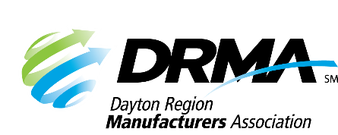
DRMA
22 E. Fifth St. ● Dayton, OH 45402
(937) 949-4000 ● (937) 949-4007 fax
SKnoll@DaytonRMA.org ● www.DaytonRMA.org

DRMA Problem Solving Skills Workshop Series
Registration Form

Please complete and return this form with payment to confirm your registration for the DRMA Problem Solving Skills Series, presented by the Workforce Division of Sinclair College. A certificate will be provided with completion at the end of each session.

Course Options
Session #1 – Define the Problem – Friday, March 13
Session #2 – Measure the Current State – Friday, May 8
Session #3 – Analyze the Root Cause – Friday, June 26
Session #4 – Analyze the Process – Friday, August 28
Session #5 –Sustainable Process Control – Friday, October 30

Time: 8:00 a.m. – 12:00 p.m.

Location: All courses will be held at Sinclair’s Centerville Campus (5800 Clyo Rd., Centerville, OH 45459).

Cost: $1,100 per person which includes a continental breakfast and individualized support from the instructor on an improvement project selected by each participating company. Notice of cancellation must be received by end of day on the Thursday prior to the class to receive a refund.

Registrant Information
Company: |  | Email receipt to:
Name | Title | Email

Payment Information
Number of Participants: |  | X $1,100 = | TOTAL = $

Check (make payable to DRMA) |  |  |  |  |  |  |  |  |  |  | Credit card (all major cards accepted)
Card #:
Exp. Date: |  |  |  |  |  | CVV Code: |  |  |  |  |  |  |  | Billing Zip Code:

Return this form with payment to the DRMA office.

If you prefer, you may call the office at 937-949-4000 to place your payment with DRMA staff after you’ve emailed/faxed your form.

