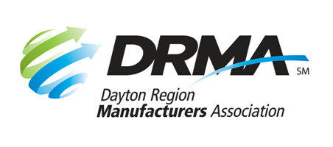

22 E. Fifth St. Dayton, OH 45402

P: (937) 949-4000 F: (937) 949-4007

[www.daytonrma.org](http://www.daytonrma.org)

**SPONSORSHIP ORDER FORM**

**Annual Meeting**

**December 3, 2025 – NCR Country Club**

Promote your products, services, and expertise at the DRMA Annual Meeting held in early December. Anticipated attendance is 140+. Contact the DRMA office at (937) 949-4000 or [Events@DaytonRMA.org](mailto:Events@DaytonRMA.org).

|  |  |  |
| --- | --- | --- |
|  | **Presenting Sponsor**  $1,000  (1 available) | **Supporting Sponsor**  $500  (unlimited) |
| Name appears as “presented by” on all event promotion (newsletter, emails, website, etc.) | Yes |  |
| Recognition on DRMA website event page and PowerPoint presentation | Logo | Name |
| Newsletter article (written by you) | 1 |  |
| Complimentary tickets  for sponsor’s guests or employees | 4 | 2 |
| Sponsor ribbons  on all sponsor employees’ name badges | Yes | Yes |
| Display table at event | Yes | Yes |
| Recognition during program | Make remarks (1 minute) | Company name & promotional sentence in script |
| Literature/giveaways on tables  provided by you | Yes |  |
| Attendee list (name and company name) | Yes |  |
| Sponsorship selected: |  |  |

*Details regarding format, content, logistics, etc., will be discussed with you before the event.*

|  |  |  |  |
| --- | --- | --- | --- |
| Company: |  | Phone: |  |
|  |  |  |  |
| Contact Name: |  | Email: |  |
|  |  |  |  |
| Date Submitted: |  | Total $: |  |

|  |  |  |  |  |  |  |  |  |  |  |  |  |  |  |  |  |  |  |  |  |
| --- | --- | --- | --- | --- | --- | --- | --- | --- | --- | --- | --- | --- | --- | --- | --- | --- | --- | --- | --- | --- |
| Check (make payable to DRMA) | | | | | | | | | | Credit card (all major cards accepted) | | | | | | | | | | |
|  | | | | | | | | | | | | | | | | | | | | |
| **Card #:** |  |  |  |  |  | |  |  | |  |  |  | |  |  |  | |  |  |  |
| **Exp. Date:** |  | | | | | **CVV Code:** | | |  | | | | **Billing Zip Code:** | | | |  | | | |
|  |  | | | | | | | | | | | | | | | | | | | |

**Return this form with payment to the DRMA office.**

If you prefer, you may call the office at 937-949-4000 to place your payment with DRMA staff **after** you’ve emailed/faxed your form.